Mobile Application Framework

1. There are 3 main types of applications. Native, Hybrid and Web apps. A native application is a software application specified with a specific programming language for either iOS or android. Native iOS apps are written in Swift language and android apps are written in Java.

Hybrid applications run on both platforms, iOS and android. This is a cross platform application type.

Web apps are accessed through a web address not the app stores. It runs from a browser with access device features. It can also be made using HTML and CSS

For the “ToDoNotes” app, I would build it using the hybrid framework. This is because the application needs to be developed within a short period of time and should be accessible to everyone. You can save money also by using this framework and it requires only one codebase to manage therefore it’s easier and quicker to make.

1. Pros and cons of Hybrid app framework: -

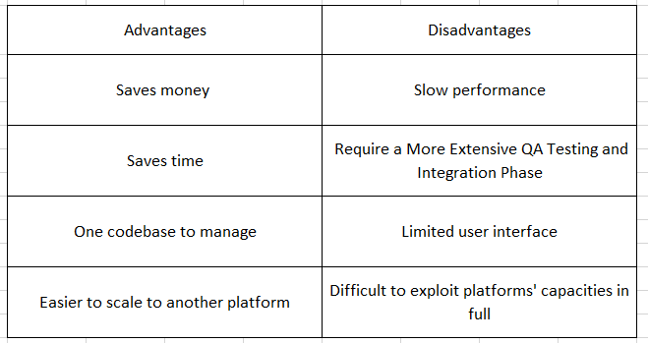

Pros and Cons of Native app framework: -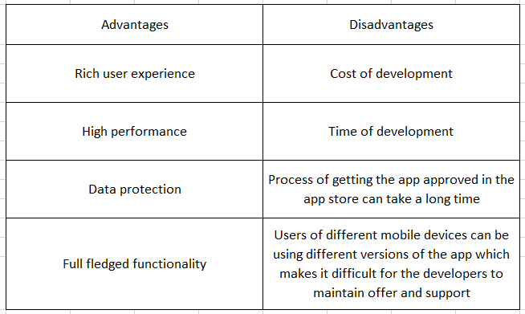



1. I feel that adding a date and time for the task to be completed next to the “ToDoNotes” would be very beneficial for people like me who tend to forget easily. If a date and time is provided, it would be easier to remember why the user has updated that specific task to be done.

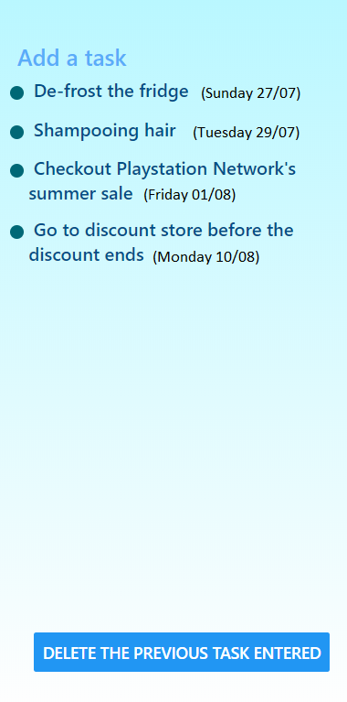

1. There are considerations that needs to be done before developing an app framework. Before developing an app, you need to make sure what your **target audience** is. You need to verify on the **platform** you are going to build an app to decide the framework. **Time** is also a very important factor in deciding a framework, depending on the time you need to complete making an app, and so is **cost.** You also need to make sure how the **design** looks and for the **security** measures depending on the target audience.
2. Snapchat. This is the application that I find myself using most which I also favor the most. The features are very fun and it’s an application which keeps you connected. The ‘streak’ feature even though it may get annoying (spams by people) it is a good feature to stay connected even if you don’t communicate much with friends that you have not really gotten in touch with. I love how specific it is. By this I mean the main feature is to take a snap shot of the current moment and sending with a caption. Sending pictures like this with texts written is also a fun way to communicate and make things more interesting. It also has a section where there are updates of news if you have subscribed and current trends people are following. I am someone who barely reads news from newspapers or news sites and this app makes me choose from a particular channel with videos and pictures which is very interesting. Snapchat also has a very secure ‘My eyes only’. This is a section where you can store pictures and videos and requires a password to access this section. There is no ‘forget password’ in that section and it’s quite safe. There is also a map section in snapchat. But if you hide your location, your friends will not be able to see your location. The map section has heat-zones on the world map which when you click, you can see public stories people have posted in that area.

**Screenshot of my ‘ToDoNotes’**

